UNITED STATES
SECURITIES AND EXCHANGE COMMISSION
Washington, D.C. 20549

FORM 6-K

REPORT OF FOREIGN ISSUER
PURSUANT TO RULE 13a-16 OR 15d-16 OF
THE SECURITIES EXCHANGE ACT OF 1934

For the month of August 2026

Commission file number: 001-39278

Kingsoft Cloud Holdings Limited
(Exact Name of Registrant as Specified in Its Charter)

Building D, Xiaomi Science and Technology Park, No. 33 Xierqi Middle Road,
Haidian District
Beijing, 100085, the People’s Republic of China
(Address of Principal Executive Offices)

Indicate by check mark whether the registrant files or will file annual reports under cover Form 20-F or Form 40-F.

Form 20-F ☒ Form 40-F ☐

EXHIBIT INDEX

Exhibit No. |  | Description
99.1 |  | Monthly Return for Equity Issuer on Movements in Securities
99.2 |  | Announcement — Date of Board Meeting

SIGNATURE

Pursuant to the requirements of the Securities Exchange Act of 1934, the registrant has duly caused this report to be signed on its behalf by the undersigned, thereunto duly authorized.

 | Kingsoft Cloud Holdings Limited
Date: August 6, 2026 | By: | /s/ Yi Li
 |  | Name: | Yi Li
 |  | Title: | Chief Financial Officer

Exhibit 99.1
 | 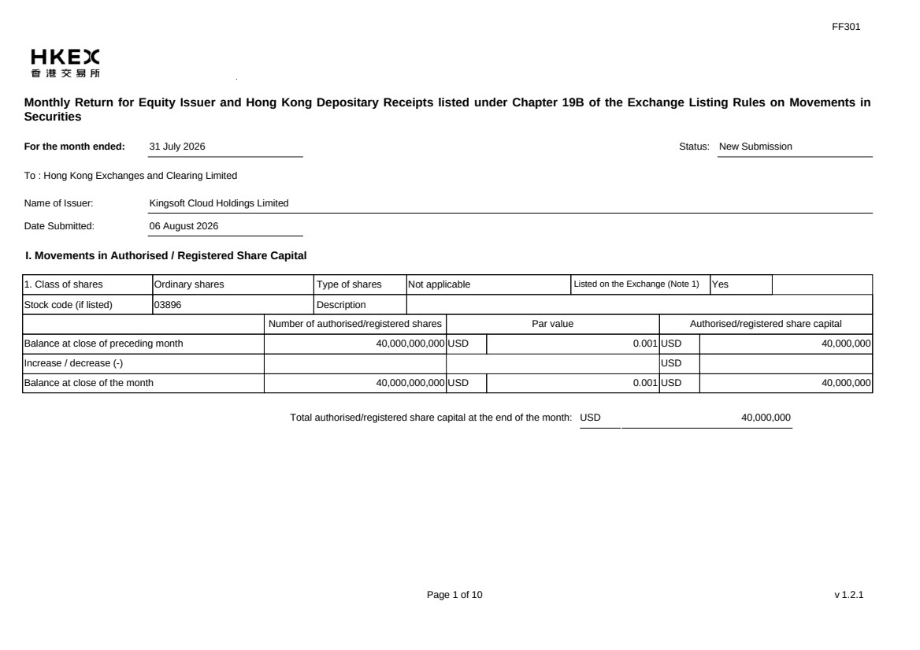 | FF301 Page 1 of 10 v 1.2.1 Monthly Return for Equity Issuer and Hong Kong Depositary Receipts listed under Chapter 19B of the Exchange Listing Rules on Movements in Securities For the month ended: 31 July 2026 Status: New Submission To : Hong Kong Exchanges and Clearing Limited Name of Issuer: Kingsoft Cloud Holdings Limited Date Submitted: 06 August 2026 I. Movements in Authorised / Registered Share Capital 1. Class of shares Ordinary shares Type of shares Not applicable Listed on the Exchange (Note 1) Yes Stock code (if listed) 03896 Description Number of authorised/registered shares Par value Authorised/registered share capital Balance at close of preceding month 40,000,000,000 USD 0.001 USD 40,000,000 Increase / decrease (-) USD Balance at close of the month 40,000,000,000 USD 0.001 USD 40,000,000 Total authorised/registered share capital at the end of the month: USD 40,000,000
 | 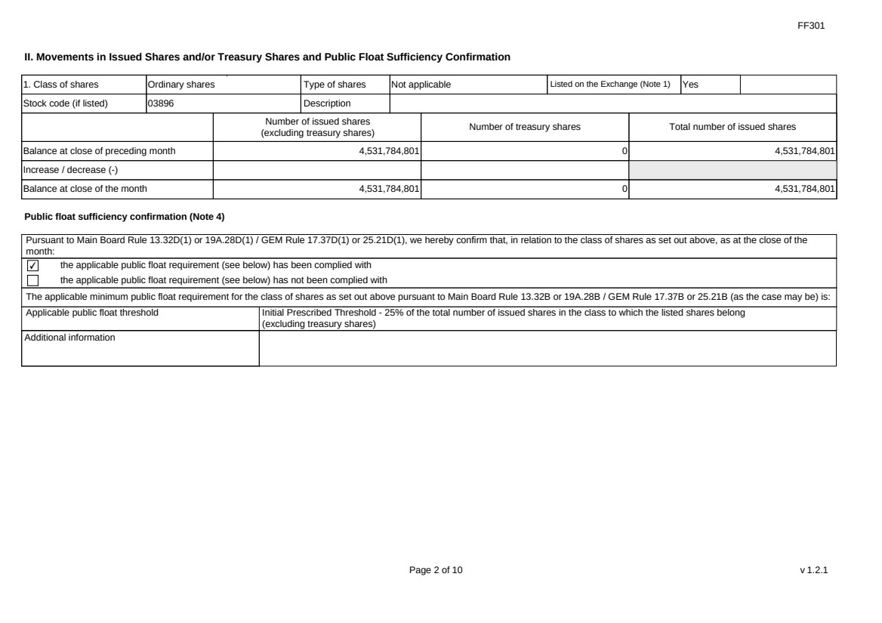 | FF301 Page 2 of 10 v 1.2.1 II. Movements in Issued Shares and/or Treasury Shares and Public Float Sufficiency Confirmation 1. Class of shares Ordinary shares Type of shares Not applicable Listed on the Exchange (Note 1) Yes Stock code (if listed) 03896 Description Number of issued shares (excluding treasury shares) Number of treasury shares Total number of issued shares Balance at close of preceding month 4,531,784,801 0 4,531,784,801 Increase / decrease (-) Balance at close of the month 4,531,784,801 0 4,531,784,801 Public float sufficiency confirmation (Note 4) Pursuant to Main Board Rule 13.32D(1) or 19A.28D(1) / GEM Rule 17.37D(1) or 25.21D(1), we hereby confirm that, in relation to the class of shares as set out above, as at the close of the month: ✔ the applicable public float requirement (see below) has been complied with the applicable public float requirement (see below) has not been complied with The applicable minimum public float requirement for the class of shares as set out above pursuant to Main Board Rule 13.32B or 19A.28B / GEM Rule 17.37B or 25.21B (as the case may be) is: Applicable public float threshold Initial Prescribed Threshold - 25% of the total number of issued shares in the class to which the listed shares belong (excluding treasury shares) Additional information
 | 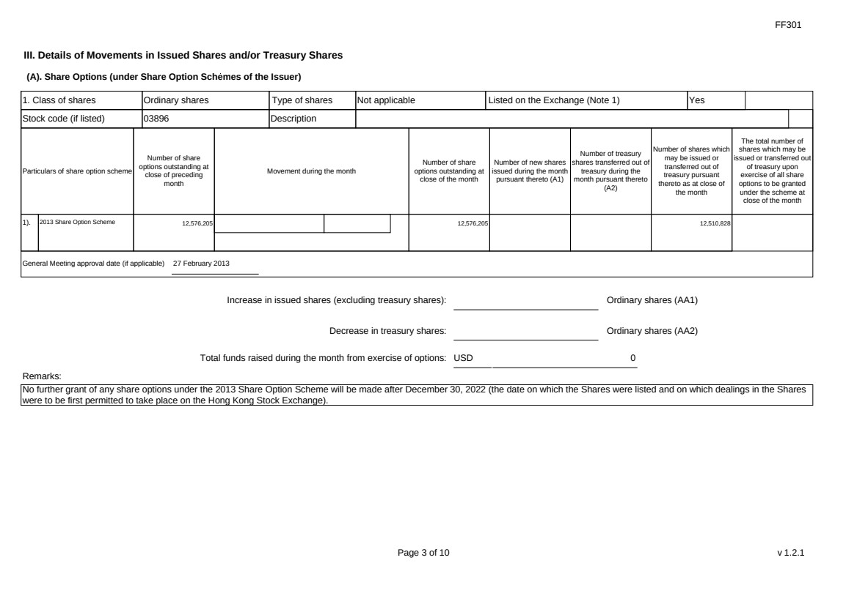 | FF301 Page 3 of 10 v 1.2.1 III. Details of Movements in Issued Shares and/or Treasury Shares (A). Share Options (under Share Option Schemes of the Issuer) 1. Class of shares Ordinary shares Type of shares Not applicable Listed on the Exchange (Note 1) Yes Stock code (if listed) 03896 Description Particulars of share option scheme Number of share options outstanding at close of preceding month Movement during the month Number of share options outstanding at close of the month Number of new shares issued during the month pursuant thereto (A1) Number of treasury shares transferred out of treasury during the month pursuant thereto (A2) Number of shares which may be issued or transferred out of treasury pursuant thereto as at close of the month The total number of shares which may be issued or transferred out of treasury upon exercise of all share options to be granted under the scheme at close of the month 1). 2013 Share Option Scheme 12,576,205 12,576,205 12,510,828 General Meeting approval date (if applicable) 27 February 2013 Increase in issued shares (excluding treasury shares): Ordinary shares (AA1) Decrease in treasury shares: Ordinary shares (AA2) Total funds raised during the month from exercise of options: USD 0 Remarks: No further grant of any share options under the 2013 Share Option Scheme will be made after December 30, 2022 (the date on which the Shares were listed and on which dealings in the Shares were to be first permitted to take place on the Hong Kong Stock Exchange).
 |  | FF301 Page 4 of 10 v 1.2.1 (B). Warrants to Issue Shares of the Issuer Not applicable
 | 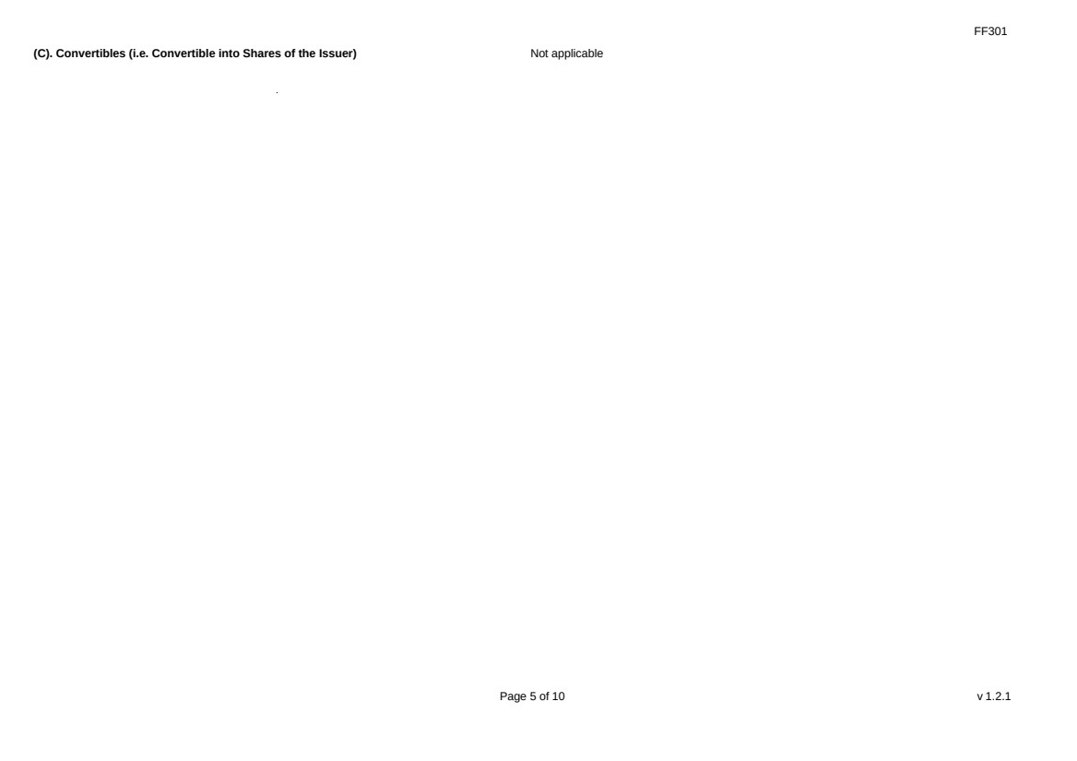 | FF301 Page 5 of 10 v 1.2.1 (C). Convertibles (i.e. Convertible into Shares of the Issuer) Not applicable
 | 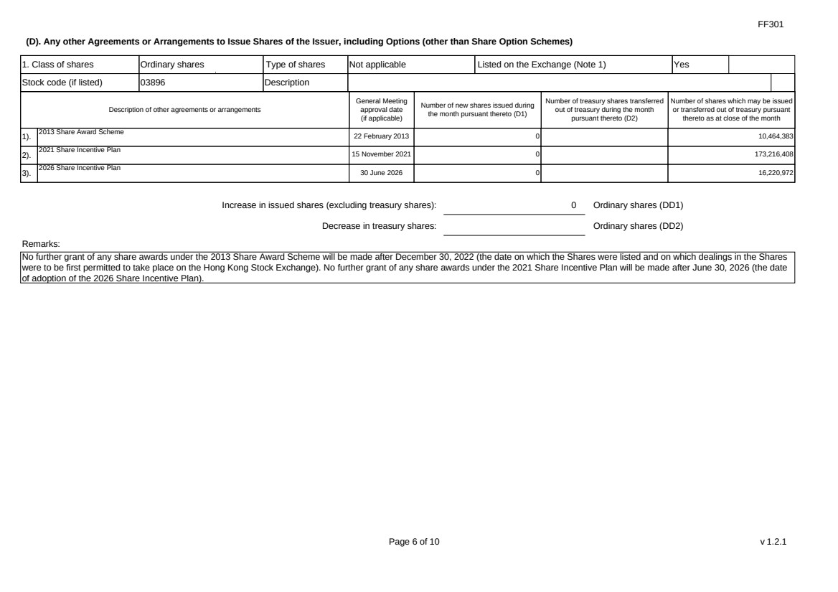 | FF301 Page 6 of 10 v 1.2.1 (D). Any other Agreements or Arrangements to Issue Shares of the Issuer, including Options (other than Share Option Schemes) 1. Class of shares Ordinary shares Type of shares Not applicable Listed on the Exchange (Note 1) Yes Stock code (if listed) 03896 Description Description of other agreements or arrangements General Meeting approval date (if applicable) Number of new shares issued during the month pursuant thereto (D1) Number of treasury shares transferred out of treasury during the month pursuant thereto (D2) Number of shares which may be issued or transferred out of treasury pursuant thereto as at close of the month 1). 2013 Share Award Scheme 22 February 2013 0 10,464,383 2). 2021 Share Incentive Plan 15 November 2021 0 173,216,408 3). 2026 Share Incentive Plan 30 June 2026 0 16,220,972 Increase in issued shares (excluding treasury shares): 0 Ordinary shares (DD1) Decrease in treasury shares: Ordinary shares (DD2) Remarks: No further grant of any share awards under the 2013 Share Award Scheme will be made after December 30, 2022 (the date on which the Shares were listed and on which dealings in the Shares were to be first permitted to take place on the Hong Kong Stock Exchange). No further grant of any share awards under the 2021 Share Incentive Plan will be made after June 30, 2026 (the date of adoption of the 2026 Share Incentive Plan).
 | 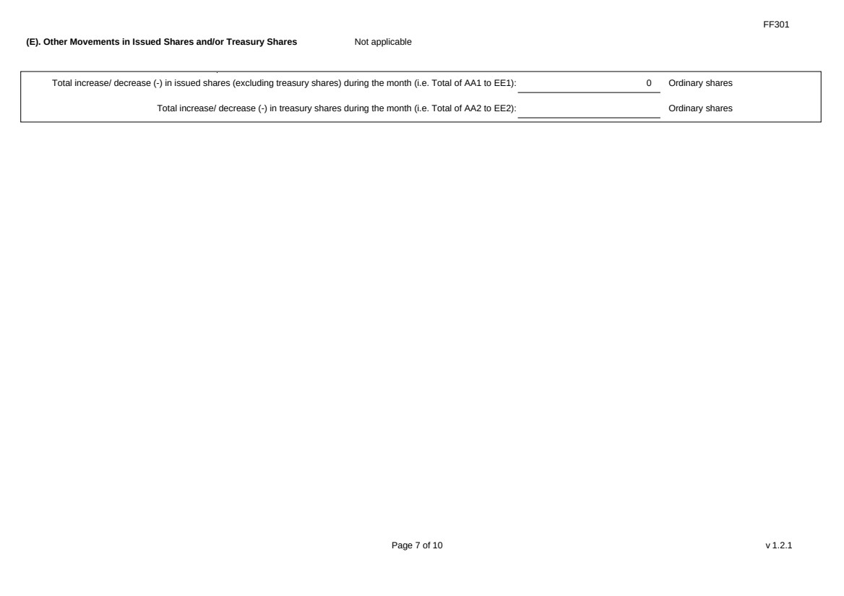 | FF301 Page 7 of 10 v 1.2.1 (E). Other Movements in Issued Shares and/or Treasury Shares Not applicable Total increase/ decrease (-) in issued shares (excluding treasury shares) during the month (i.e. Total of AA1 to EE1): 0 Ordinary shares Total increase/ decrease (-) in treasury shares during the month (i.e. Total of AA2 to EE2): Ordinary shares
 | 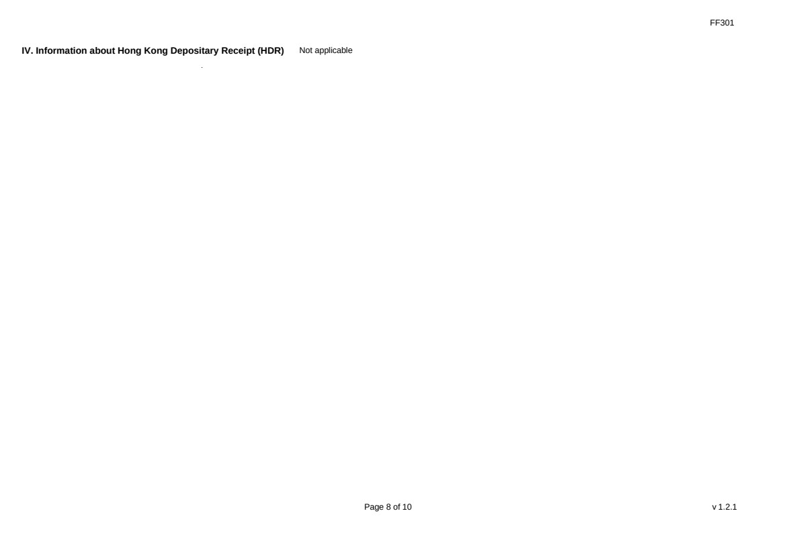 | FF301 Page 8 of 10 v 1.2.1 IV. Information about Hong Kong Depositary Receipt (HDR) Not applicable
 | 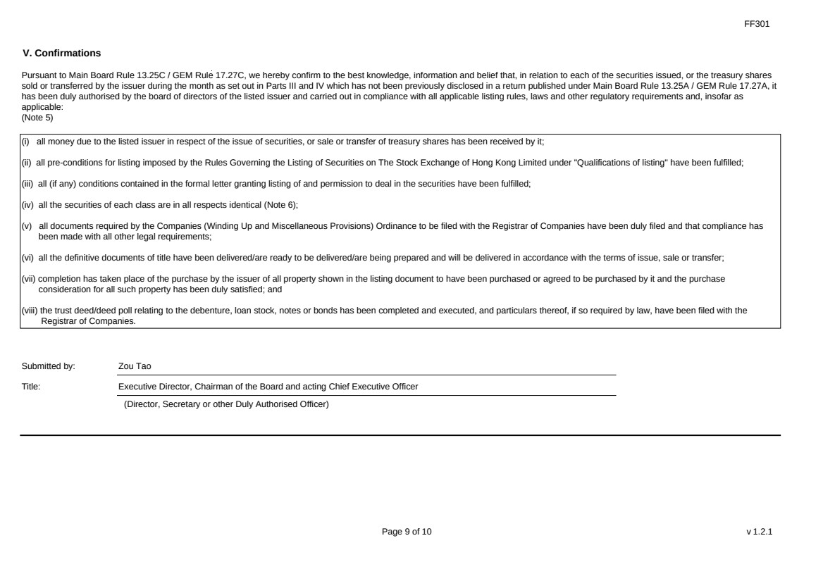 | FF301 Page 9 of 10 v 1.2.1 V. Confirmations Pursuant to Main Board Rule 13.25C / GEM Rule 17.27C, we hereby confirm to the best knowledge, information and belief that, in relation to each of the securities issued, or the treasury shares sold or transferred by the issuer during the month as set out in Parts III and IV which has not been previously disclosed in a return published under Main Board Rule 13.25A / GEM Rule 17.27A, it has been duly authorised by the board of directors of the listed issuer and carried out in compliance with all applicable listing rules, laws and other regulatory requirements and, insofar as applicable: (Note 5) (i) all money due to the listed issuer in respect of the issue of securities, or sale or transfer of treasury shares has been received by it; (ii) all pre-conditions for listing imposed by the Rules Governing the Listing of Securities on The Stock Exchange of Hong Kong Limited under "Qualifications of listing" have been fulfilled; (iii) all (if any) conditions contained in the formal letter granting listing of and permission to deal in the securities have been fulfilled; (iv) all the securities of each class are in all respects identical (Note 6); (v) all documents required by the Companies (Winding Up and Miscellaneous Provisions) Ordinance to be filed with the Registrar of Companies have been duly filed and that compliance has been made with all other legal requirements; (vi) all the definitive documents of title have been delivered/are ready to be delivered/are being prepared and will be delivered in accordance with the terms of issue, sale or transfer; (vii) completion has taken place of the purchase by the issuer of all property shown in the listing document to have been purchased or agreed to be purchased by it and the purchase consideration for all such property has been duly satisfied; and (viii) the trust deed/deed poll relating to the debenture, loan stock, notes or bonds has been completed and executed, and particulars thereof, if so required by law, have been filed with the Registrar of Companies. Submitted by: Zou Tao Title: Executive Director, Chairman of the Board and acting Chief Executive Officer (Director, Secretary or other Duly Authorised Officer)
 | 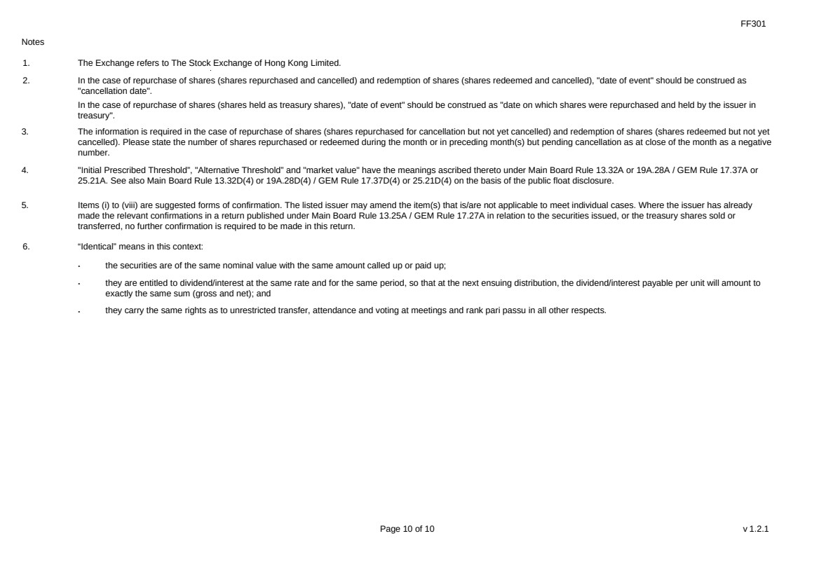 | FF301 Page 10 of 10 v 1.2.1 Notes 1. The Exchange refers to The Stock Exchange of Hong Kong Limited. 2. In the case of repurchase of shares (shares repurchased and cancelled) and redemption of shares (shares redeemed and cancelled), "date of event" should be construed as "cancellation date". In the case of repurchase of shares (shares held as treasury shares), "date of event" should be construed as "date on which shares were repurchased and held by the issuer in treasury". 3. The information is required in the case of repurchase of shares (shares repurchased for cancellation but not yet cancelled) and redemption of shares (shares redeemed but not yet cancelled). Please state the number of shares repurchased or redeemed during the month or in preceding month(s) but pending cancellation as at close of the month as a negative number. 4. "Initial Prescribed Threshold”, "Alternative Threshold” and "market value" have the meanings ascribed thereto under Main Board Rule 13.32A or 19A.28A / GEM Rule 17.37A or 25.21A. See also Main Board Rule 13.32D(4) or 19A.28D(4) / GEM Rule 17.37D(4) or 25.21D(4) on the basis of the public float disclosure. 5. Items (i) to (viii) are suggested forms of confirmation. The listed issuer may amend the item(s) that is/are not applicable to meet individual cases. Where the issuer has already made the relevant confirmations in a return published under Main Board Rule 13.25A / GEM Rule 17.27A in relation to the securities issued, or the treasury shares sold or transferred, no further confirmation is required to be made in this return. 6. “Identical” means in this context: ． the securities are of the same nominal value with the same amount called up or paid up; ． they are entitled to dividend/interest at the same rate and for the same period, so that at the next ensuing distribution, the dividend/interest payable per unit will amount to exactly the same sum (gross and net); and ． they carry the same rights as to unrestricted transfer, attendance and voting at meetings and rank pari passu in all other respects.

Exhibit 99.2

Hong Kong Exchanges and Clearing Limited and The Stock Exchange of Hong Kong Limited take no responsibility for the contents of this announcement, make no representation as to its accuracy or completeness and expressly disclaim any liability whatsoever for any loss howsoever arising from or in reliance upon the whole or any part of the contents of this announcement.


Kingsoft Cloud Holdings Limited
金山云控股有限公司
(Incorporated in the Cayman Islands with limited liability)
(Stock Code: 3896)
(Nasdaq Stock Ticker: KC)

DATE OF BOARD MEETING

The board of directors (the “Board”) of Kingsoft Cloud Holdings Limited (the “Company”) hereby announces that a meeting of the Board will be held on Wednesday, August 19, 2026, for the purpose of considering and approving, among other matters, (i) the unaudited second quarterly results of the Company, its subsidiaries and consolidated affiliated entities (collectively, the “Group”) for the three months ended June 30, 2026 and its publication, and (ii) the unaudited interim consolidated results of the Group for the six months ended June 30, 2026 and its publication.

The Company’s management will hold an earnings conference call on Wednesday, August 19, 2026, at 8:15 P.M. Beijing/Hong Kong Time (or 8:15 A.M. U.S. Eastern Time on the same day).

For participants who wish to join the call, please complete online registration using the link provided below prior to the scheduled call start time. Upon registration, each participant will receive access details for this conference including a conference access code, a PIN number (personal access code), the dial-in number, and an e-mail with detailed instructions to join the conference call.

Participant Online Registration:

https://register-conf.media-server.com/register/BIf61186884fdb445fabf9794d01884399

A live and archived webcast of the conference call will also be available at the Company’s investor relations website at https://ir.ksyun.com.

By Order of the Board
Kingsoft Cloud Holdings Limited
Mr. Zou Tao
Chairman of the Board, Executive Director, and acting Chief Executive Officer

Hong Kong, August 6, 2026

As at the date of this announcement, the board of directors of the Company comprises Mr. Zou Tao as Chairman and executive director, Mr. Qu Heng and Mr. Zhang Duo as non-executive directors, and Mr. Yu Mingto, Mr. Wang Hang and Ms. Qu Jingyuan as independent non-executive directors.

