UNITED STATES

SECURITIES AND EXCHANGE COMMISSION

Washington, D.C. 20549

FORM 6-K

REPORT OF FOREIGN ISSUER

PURSUANT TO RULE 13a-16 OR 15d-16 OF

THE SECURITIES EXCHANGE ACT OF 1934

For the month of January 2023

Commission file number: 001-39278

Kingsoft Cloud Holdings Limited

(Exact Name of Registrant as Specified in Its Charter)

Building E, Xiaomi Science and Technology Park, No. 33 Xierqi Middle Road,

Haidian District

Beijing, 100085, the People’s Republic of China

(Address of Principal Executive Offices)

Indicate by check mark whether the registrant files or will file annual reports under cover Form 20-F or Form 40-F.

Form 20-F ☒ Form 40-F ☐

Indicate by check mark if the registrant is submitting the Form 6-K in paper as permitted by Regulation S-T Rule 101(b)(1): ☐

Indicate by check mark if the registrant is submitting the Form 6-K in paper as permitted by Regulation S-T Rule 101(b)(7): ☐

EXHIBIT INDEX

Exhibit No. Description

99.1 Announcement on The Stock Exchange of Hong Kong Limited Regarding Liquidity Arrangements, dated January 6, 2023

SIGNATURE

Pursuant to the requirements of the Securities Exchange Act of 1934, the registrant has duly caused this report to be signed on its behalf by the undersigned, thereunto duly authorized.

 | Kingsoft Cloud Holdings Limited
Date: January 6, 2023 | By: /s/ Haijian He
 |  | Name: Haijian He
 |  | Title: Chief Financial Officer and Director

Exhibit 99.1

Hong Kong Exchanges and Clearing Limited, The Stock Exchange of Hong Kong Limited (the “Hong Kong Stock Exchange”) and Hong Kong Securities Clearing Company Limited take no responsibility for the contents of this announcement, make no representation as to its accuracy or completeness and expressly disclaim any liability whatsoever for any loss howsoever arising from or in reliance upon the whole or any part of the contents of this announcement.

This announcement is for information purposes only and does not constitute an offer or an invitation by any person to acquire, purchase or subscribe for shares or other securities of Kingsoft Cloud Holdings Limited (the “Company”). Prospective investors should read the listing document dated December 23, 2022 (the “Listing Document”) issued by the Company for detailed information about the Company.

This announcement is not an offer of securities for sale in the United States. No securities may be offered or sold in the United States absent registration or an exemption from registration. Any public offering of securities in the United States will be made by means of a prospectus that may be obtained from the issuer or the selling securities holder and that will contain detailed information about the company and management, as well as financial statements.

Unless otherwise defined in this announcement, capitalized terms in this announcement shall have the same meanings as those defined in the Listing Document.


Kingsoft Cloud Holdings Limited

金山云控股有限公司*

(Incorporated in the Cayman Islands with limited liability)

(Stock Code: 3896)

(Nasdaq Stock Ticker: KC)

LISTING BY WAY OF INTRODUCTION

ON THE MAIN BOARD OF

THE STOCK EXCHANGE OF HONG KONG LIMITED

Liquidity Arrangements regarding the Average Daily Trading Volume of the Shares on the Hong Kong Stock Exchange

Joint Sponsors

Joint Financial Advisors
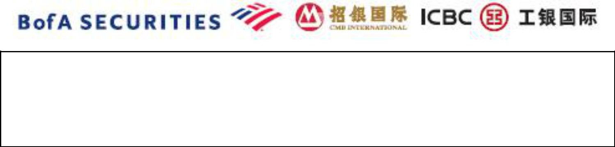

The Company issues this announcement to provide updates on the average daily trading volume of its Shares on the Hong Kong Stock Exchange.

Prospective investors should refer to the Listing Document (including the section headed “Risk Factors” contained in the Listing Document), the formal notice dated December 23, 2022 (the “Formal Notice”), the announcement regarding clarification on Formal Notice dated December 28, 2022 (the “December 28 Announcement”) and the announcement regarding previous trading day trading information in respect of the ADSs on the Nasdaq dated December 30, 2022 (the “December 30 Announcement”) issued by the Company before deciding to invest in the Shares or the ADSs.

1

INTRODUCTION

We refer to the Listing Document, the Formal Notice, the December 28 Announcement and the December 30 Announcement issued by the Company.

As at the date of this announcement, the total number of issued Shares is 3,805,284,801.

LIQUIDITY ARRANGEMENTS REGARDING THE AVERAGE DAILY TRADING VOLUME OF OUR SHARES ON THE HONG KONG STOCK EXCHANGE

Dealings in our Shares on the Hong Kong Stock Exchange commenced on December 30, 2022.

As stated in the section headed “Listings, Registration, Dealings and Settlement” in the Listing Document, the Designated Period is 90 calendar days from and including the Listing Date, in which trading activities can be carried out from the Pre-opening Session (as defined in the Rules of the Exchange) on December 30, 2022 and expiring upon the end of the Closing Auction Session (as defined in the Rules of the Exchange) on March 29, 2023.

The following table sets forth the average daily trading volume and average daily turnover of our Shares on the Hong Kong Stock Exchange from December 30, 2022 to January 6, 2023.

 |  |  |  |  | Average daily
 |  |  |  |  | trading volume
 |  |  |  |  | of our Shares
 |  |  |  |  | (as a
 |  |  |  |  | percentage
 | Average daily |  | Average daily |  | of the total
 | trading volume |  | turnover of |  | issued share
 | of our Shares |  | our Shares |  | capital of the
 | (number of |  | (in millions) |  | Company)
 | shares) |  | (HK$) |  | (%)
December 30, 2022 to January 6, 2023 | 14,786,400 |  | 43.91 |  | 0.39%

As stated in the section headed “Listings, Registration, Dealings and Settlement” in the Listing Document and the December 30 Announcement, the Company will release further announcements on liquidity arrangements regarding the accumulated average daily trading volume of our Shares on the Hong Kong Stock Exchange on a weekly basis during the Designated Period.

By Order of the Board

Kingsoft Cloud Holdings Limited

Mr. Zou Tao

Executive Director, Vice Chairman of the Board

and acting Chief Executive Officer

Hong Kong, January 6, 2023

As at the date of this announcement, the board of directors of the Company comprises Mr. Lei Jun as Chairman and non-executive director, Mr. Zou Tao as Vice Chairman and executive director, Mr. He Haijian as executive director and Dr. Ye Hangjun as non-executive director, and Mr. Yu Mingto, Mr. Wang Hang and Ms. Qu Jingyuan as independent non-executive directors.

- For identification only.

2

